**Axe DevTools**

* It is an automated and guided accessibility testing solution.

**How to use Axe Devtools**

**Step 1 :**

* Add the Axe DevTools extension in Google chrome.

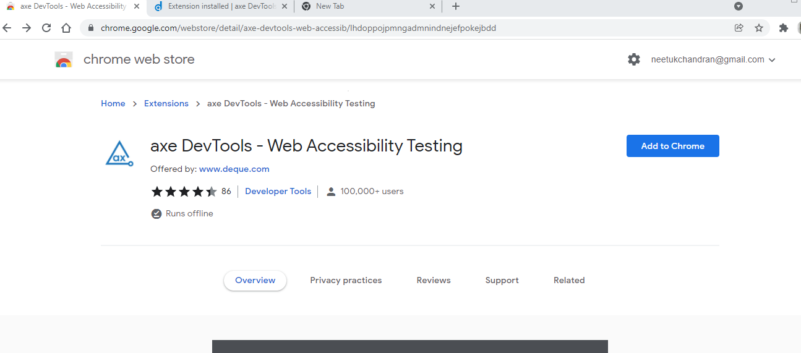

* Click Add to chrome

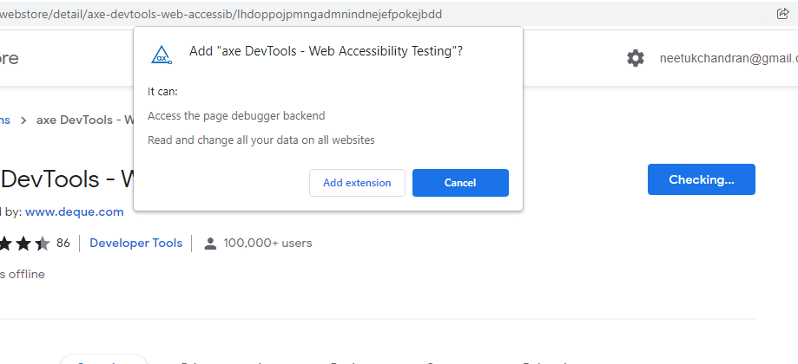

* Add Extension

**Step 2:**

* Go to the website you want to test
* In our case [www.urbanladder.com](http://www.urbanladder.com)

**Step3:**

* you can right-click on the screen and go to "Inspect"
* Navigate to axe DevTools

**Results:**

